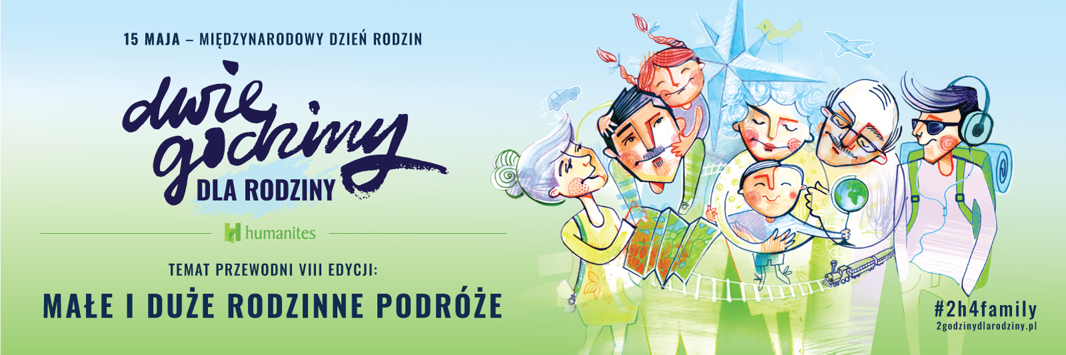

Ladies and Gentlemen,
we are very pleased to invite your company to take part in the eighth edition of our action “Two Hours for Family”. This action is here to stay in the calendar of cyclic events of nearly six hundred companies all over the world, joining this way a global social movement for deepening relations with the loved ones.

We are very happy to see the number of employers who actively join our action growing systematically. A few hundred of Polish and international companies, huge capital groups and public institutions put their trust in us, among them: Alior Bank, Allianz, Aviva, ATM, ATOS, AXA, Bosch, EFL Group, ENEL-MED, Erbud Group, Electrolux, GFK Polonia, Great Place to Work, ING Ż̇ycie, K2, MetLife, Microsoft, PKN ORLEN Group, Oracle, Pentacomp, PKO PTE, Bank PKO BP, PwC, Questa, Siemens, Tauron Group, Tchibo, Wedel, Wirtualna Polska, EY and many, many others.
It leads us to believe that business is the key engine powering social change. Based on our observations we can see that more and more entrepreneurs notice that the leadership model based on power does not pass the acid test in the age of digital economy. The more so, that – as shows the research “Specialist 2018” conducted by Pracuj.pl – the biggest motivation for employees is currently the possibility of reaching self-fulfilment and performing meaningful tasks.

Employers taking care about the family life and balance of their employees have a direct impact on the effectiveness of their work and reaching economic goals of the company, as proven by BIGRAM data. Creating favourable conditions not only for professional, but also personal growth, the employer gains the engagement of the team of people, for whom work constitutes value, not just obligation.
Many companies are in search of effective methods that would enable employees to strike the work-life-balance. They try out a lot of short-term solutions, as well as some systemic changes. Bearing in mind that not only financial motivation plays pivotal role, employees choose organisations that represent the same values and get involved in social actions.
“Two Hours for Family” matches that description very well. It is a cyclic and systemic solution for employers, who want to create space for the employees to build and strengthen family bonds. From global perspective, such actions prevent relationship crises and put in focus mental and emotional health of the employees. It is a symbol of integration of the professional and private life, according to the motto “We have just one life in many different roles”. Research conducted on all continents proves that strong and deep relations with family and friends are important condition to reach happiness, development and wellbeing of employees. This is of great importance, as we live in the world, where over 80% of diseases have psychosomatic background, and the number of suicide victims in Poland is higher than the number of casualties in traffic accidents. We live in the world, where people are more and more lonely.
Employers are increasingly aware of that. They start to notice, how difficult it is for employees to find the space for closeness outside their professional life. Modern pace of life, stress, pressure and lack of time make them devote insufficient amount of time to their loved ones.
Offering this opportunity to your employees to leave work two hours earlier on the day of the finale of “Two Hours for Family” action, that is on 15th May – on International Family Day, draws attention to work-life balance, closeness and relationships. First of all, it gives opportunity to spend quality time with the nearest and dearest – in this free afternoon your employees might decide to spend on multigenerational conversations, common games or trips, as encourages our main theme of this year’s edition: SMALL AND BIG FAMILY TRIP.

On this occasion, we have prepared another set of family game ASK ME, which gives opportunity to get to know each other better and strengthen mutual relationships. There are no points, no competition, no winners or losers. It is a game that teaches curiosity, cooperation, hearing others, telling own stories, shapes empathy and favours multigenerational integration. We do strongly recommend to purchase ASK ME game, which could be a perfect gift for the employees of your company. All details may be found on our website 2godzinydlarodziny.pl.
Lao-Tzu once said: “The journey of a thousand miles begins with one step”. We believe that you will take that step by joining our action “Two Hours for Family”.
Share this invitation with your business partners and inspire them to action.

Fond regards,

Zofia Dzik

President of the Board and Founder of
Humanites Foundation
phone no. 504 144 784
Zofia.Dzik@humanites.pl

