Dear Colleagues,
We are delighted to share with you that our company/organization has joined – for the first time/once again – the initiative organized by the Humanites Institute:

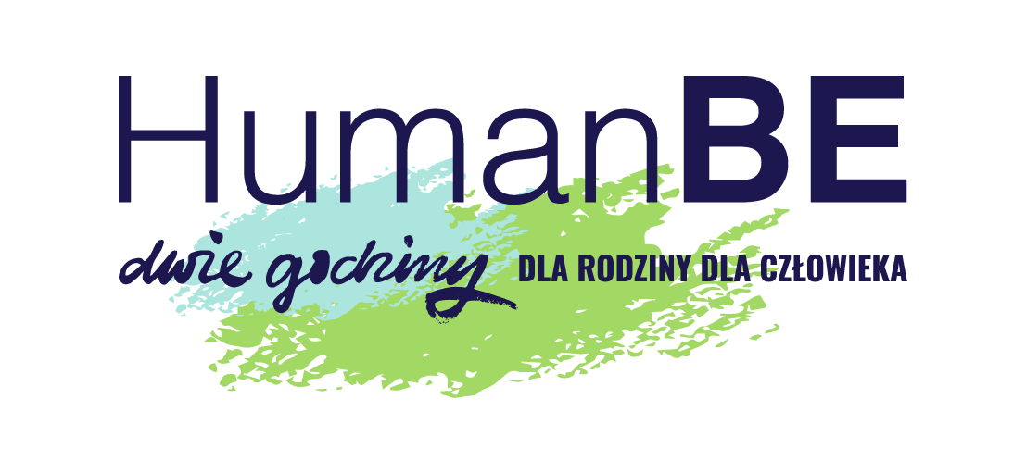

#HumanBE – Two Hours for Family | for Human
Launched in 2012 in Poland by the Humanites Institute – People & Technology, this social initiative aims to counteract the crisis of relationships and loneliness. Over the years, it has evolved into a global movement for changing work culture and lifestyle. Remarkably, more than 3,500 companies and organizations from over 50 countries worldwide – from Europe to Australia – have joined this initiative together with their employees. As an organization that values human relationships, we are proud to contribute as well.
Over 80 years of Harvard University research, focused on identifying the factors that influence health, longevity, and quality of life – both personal and professional – have shown that the key factor is simply the quality of our relationships.
For many years, the #HumanBE – Two Hours for Family / for Human initiative has inspired and reminded us of what truly matters – the importance of relationships in a fast-paced world shaped by a dynamic technological revolution. It highlights that our professional and personal lives are deeply interconnected, and the quality of our relationships impacts both.
The initiative brings people closer – at home and at work. It helps us rediscover those who are often right next to us: in our families, at the desk nearby, or on the other side of a screen during online meetings. As we increasingly move away from multi-generational living, we risk losing access to valuable stories, experiences, and conversations that remain untold.
Each year, HumanBE is accompanied by a different motto, inviting us to spend meaningful time together and build shared experiences. In 2025, the theme will be:
„CULTURE Connects GENERATIONS”.

What awaits you?
Around this theme, we have prepared a range of activities/inspirations/ideas for you (space for a customized program description within your organization).

What does this mean for you?
(Option for companies that offer symbolic 2-hour time off)
Our company would like to offer you something truly valuable – two symbolic hours of free time. You can use them on May 15 or at another convenient time (details to be specified). We encourage you to spend this time with your loved ones – family, friends, or colleagues. We want you to build strong relationships not only at work but also in your everyday life. A happy employee is a better employee – and we truly believe that!
Alternatively:
What the company/organization would like to offer you is, in essence, invaluable – two symbolic hours of free time (details on how to use them can be added here). We encourage you to dedicate this time to your loved ones. We want you to nurture meaningful relationships not only at work but also at home and among friends. Work and home are interconnected systems – we carry energy from one into the other. We wish you a wonderful time – feel free to use our inspirations as well as those provided by the initiative organizers at www.2godzinydlarodziny.pl

(Option for companies using ASK ME cards)
We would also like to offer you Ask Me cards, designed to support relationship-building. It’s a simple game that helps you get to know your loved ones better – across generations at home, as well as your colleagues at work. There are no points, no competition, no losers – what matters is curiosity about another person: their memories, experiences, and passions.

We hope that participating in #HumanBE #2h4family #4Human will bring you and your loved ones joy. We also appreciate you in your everyday roles: as parents, children, siblings, grandparents, grandchildren, friends, partners, citizens – simply as human beings.
We invite you to join in this shared experience – to celebrate relationships, strengthen connections, and discover one another. Take time to connect with your loved ones, and also as a team – use the materials provided to get to know each other better.
If you participate and share your experiences on social media, please remember to include the hashtags #HumanBE #2h4family, so that this idea of global change, initiated in Poland, can reach even further – bringing people closer and giving them the joy of conversation, shared time, and simply being together.

Here are some inspirations for conversations and shared moments:

Around the theme of Culture
This year, we invite you to explore culture together – through conversations, shared experiences, or trying something new:
- Visit a museum, gallery, or historical place in your area with family or friends. Afterwards, talk about your impressions – even familiar places can be rediscovered together.
- Create a collage together using paper, glue, scissors, and magazines. Themes could include: “Who we are”, “What matters to us as a family”, “Our roots and wings”.
- Choose a classic European work – e.g. The Divine Comedy, Madame Bovary, Maiden Vows by Fredro, or even Winnie-the-Pooh, celebrating its 100th anniversary in 2026. Read it aloud together and reflect on its meaning today for us human beings.
- Create your own “All-Time List” of the most important places, works (films, music, art, etc.) everyone should experience at least once in life.
- Consider preparing a small theatre like performance with family, friends, or neighbors using publicly available scripts.

Moments of memories and laughter
- What is your favorite book? And your loved ones’?
- What is your favorite series? And of those close to you?
- What was your favorite childhood cartoon? And your loved ones?
- Do you enjoy visiting museums or galleries? Why or why not? Do you visit them on your own? With someone?
- What makes your loved ones happiest? Who is it? Partner? Mom? Dad? Friend? Grandpa?
- What’s the craziest thing you’ve ever done? (the question of the high risk)
- What gift brought you the most joy? What was it? From whom?
- What were your school trips like? Which one is the most memorable?
- What is the funniest movie you’ve seen?
- Which recent film stayed with, touched you the most?
- Talk about your favorite music – how has your taste evolved over the time? Enjoy a joint music evening – when everyone plays a piece of the favourate music.

Let your imagination run free!
- Will people still watch series in 100 years? What will replace them?
- You land on a deserted island – choose three films to watch over and over. What would be your choice and why?.
- Change the ending of a selected book or film – what would you propose?
- If you were artists, what would you create and why? Visual art, literature, music, film? Explain your choices? Or maybe perhaps someone of you has practiced some art?

