Dear Colleagues,
we are pleased to announce that once again/for the first time we are actively involved in the Global Social Movement for closeness “Two Hours for Family/ Two Hours for Human”, initiated by the Humanites Institute over nine years ago. The action is a response to the growing phenomenon of loneliness, depression and the breakdown of interpersonal relationships, including the breakdown
of families which results from the pace of our lives.
Our observations show that the movement, abbreviated as #2h4family, aimed at strengthening relationships between people through, inter alia, building good rituals, encouraging good, interesting intergenerational conversations and joint activities, both in families and at work, received a very positive response in Poland and abroad. Employers from 18 countries have already joined this movement. We are glad that our company can be a part of it as well. The issue of well-being is highly important to us. We do believe, however, that every person is a system of interconnected vessels. And this year we are particularly happy because this year’s main theme of the action “SPORT THROUGH GENERATIONS” offers many opportunities to strengthen relationships and to enjoy the activity we need, despite the pandemic restrictions.
We are aware of the important roles you play outside of work and how many tasks you perform in your everyday life, in your families, communities in which you live or in which you pursue your passions. The pace of life that accompanies all of us is not without significance, either. Pressure, stress and rush often mean that what is most important is lost somewhere along the way. We know what kind of tension resulting from the pandemic you have had to face so far. More and more often we feel tired, lonely and lost.
Let’s stop for a moment, let’s slow down! Let us consider what our true value is. We will discover then that our strength to act often comes from the quality of relationships with our loved ones in the family and of the relationships that we build around ourselves at work, at school, at university, or simply in life, and which we often neglect due to lack of time and fatigue. Consequently, we often reduce it to the exchange of simple information from everyday life, losing the possibility of a kind of re-discovering our loved ones again, which is the driving force of relationships, such as, for example, when falling in love.
The culmination of the action Two Hours for Family/Two Hours for Human takes place on 15th May for a reason. Did you know, it’s International Day of Families? Especially on this day, let’s use the free afternoon for joint activities with family and friends. It can also be a space for getting to know each other a bit better by the employees of our company. We want to make your task a bit easier by enabling the earlier finish of the workday on Friday, 14th May, preceding the International Day of Families, or on any other day agreed by your team. Below you can find some ideas on how to spend this time in relation to the main theme of this year’s campaign, i.e. “SPORT THROUGH GENERATIONS”.

- Talk about what sports were once popular, what sports people played, what the differences are in the approach to activity, e.g., in the open air then and now. Try to learn from each other (generationally) an activity that you have not known so far and that allows you to spend time actively. Who remembers playing deck tennis? Or hare and hounds? Hoodman-blind? Race through the room using bottle caps?
- Organise a bicycle trip. Invite as many people to participate as possible.
- Go for a picnic together – then, you could play badminton or volleyball.
- Sports-themed charades could be another opportunity to have an enjoyable afternoon – each of you could present another sports discipline, while the rest of the participants have to guess, what discipline it is.
- Do you know, who was the sports idol for your mum, dad, grandma or grandpa? What teams did they support 10, 20 years ago? Now you have the opportunity to talk to them about this and go down memory lane together.
- Dancing is also a sport. Turn on the music and dance. Make up a new dance routine, dance it together, maybe even record it for the loved ones who do not live with you, so that they can learn it, as well. It’s also fun online when you connect via zoom.
- Organize a multi-generational walk, for example to the forest or a lake. A walk is great physical activity and an opportunity to talk with each other outdoors!
- Play together the ASK ME generational game, issued by the Humanites Institute. The questions that we prepared for you will help you discover new talents of other players. And such questions as, for example, “Tell us how and when you learned to ride a bike” or “Do you know what it was like in the case of your parents, grandparents”, will be a great opportunity for
a few generations to go down the memory lane!
Everyone has their own key to closeness. We are convinced that you will find it and spend unforgettable moments together. Create your own closeness rituals as often as possible. Celebrate interesting, deep, intergenerational conversations while our loved ones are still with us, let’s discover some family stories, anecdotes, let’s preserve them for the future generations. Then, the emotions that accompanied them will stay with you for longer! Life can be full of passion and interesting activities among people close to your heart. It is only up to you, what emotions you fill them with!
[option for companies that have decided to purchase cards for employees]
On such a special occasion as #2h4family, we have prepared a gift for you – a set of ASK ME cards. This simple game gives you an extraordinary opportunity to get to know your loved ones better. There are no points in it, no competition and no losers. It is a game in which the rules are dictated by curiosity.
Feel invited to have fun and spread the idea of the Global Social Movement “Two Hours for Family”. Let’s inspire others with our example. While playing, having fun with your families, share with us the best questions or stories that you heard, maybe even a photo. Tag it with #2h4family and post it on your social media. Let’s all support the idea and show that “Two Hours for Family” really does bring people closer.
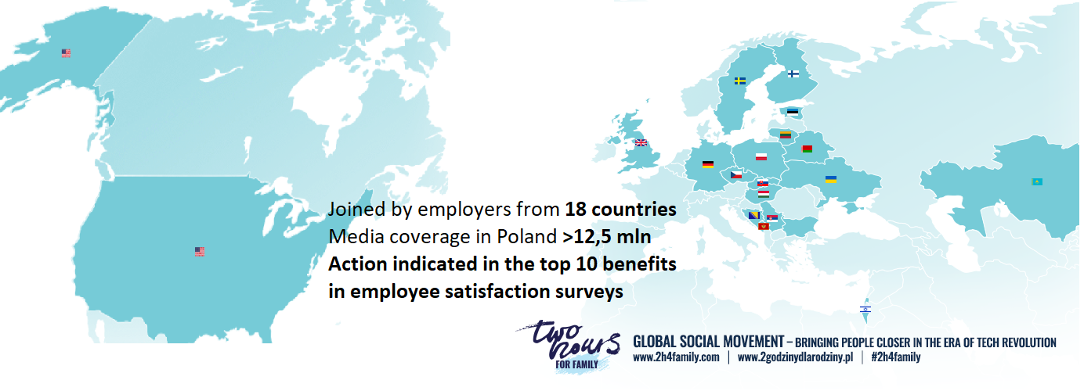
With kind regards,

