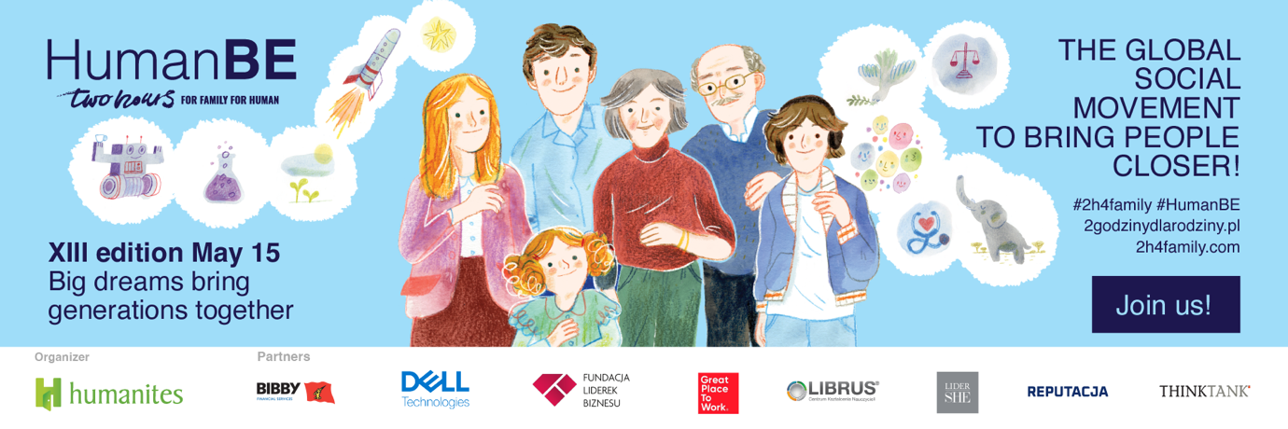
Dear Sir/Madam,

The Humanities Institute - Human&Technology is honored and pleased to invite you to participate in the 13th edition of the Two Hours for Family | HumanBE campaign, the first Polish well-being initiative for Employers. Our campaign aims to remind everyone of the importance of closeness and relationships and to support activities that build bonds within the family, with loved ones, and at work.

Two Hours for Family | for Human
to be closer, not just beside each other, at home and work

#2h4family is a global movement for Great Social Change in work culture and lifestyle. Over the 13 years of its existence, more than 3000 companies and organizations from 59 countries have participated, operating in the Americas, Europe, Africa, Asia, Australia, and Oceania. We have high hopes that this year, among the leaders engaged in creating responses to the increasing phenomena of loneliness, depression, and the crisis of interpersonal bonds, your Organization will not be missing. The motivation might be to prepare companies/organizations for changes dictated by rapid technological advances, the AI revolution, and a dynamic business environment. We anticipate that the best organizations will focus on incorporating the "human factor" and building a high work culture.

The key thing we will encourage you to reflect upon during the campaign is what you, as an Employer, can do to positively affect the well-being of your Employees – both at work and in their private lives. At the heart of our campaign, we always place interpersonal relations because, in our opinion, they are the foundation not only of a successful life and happy family but also of a well-functioning business.

As every year, we will encourage you to give your employees two hours off so they can spend this time with their loved ones. We will also persuade you to organize attractions for Employees and their Families. This year's slogan is "Great dreams connect generations". Let it be an inspiration for you to implement #2h4family/4human in the most interesting way in your company, engaging your employees.

Why is it worth getting involved in the campaign?
Private happiness and a sense of purpose at work positively affect employee engagement and efficiency. This has been confirmed by scientific research, our analyses, and hundreds of conversations we have had with employers and employees. Therefore, it is beneficial to participate in our campaign, for the team's wellbeing and organizational development. Additionally, due to legislative changes, other companies will be required to report activities in the area of ESG, and the central component 'S' (social) is precisely what the Two Hours for Family / HumanBE campaign addresses.

How to get involved in the campaign?
Fill out and send us the registration form, and inspire and encourage employees to spend quality time with their closest ones as part of the International Day of Families celebration. On our website, you will also find a complete set of materials and inspirations that will facilitate the implementation of the objectives in your Company/Organization.
We wish you a wonderful celebration of #2h4family/4human in 2024!
The 'Two Hours - HumanBE ' Team and the Humanities Institute

Do you need more data?
According to the #WELLBEING Good Employer Practices 2023 report prepared by the Humanities Institute, only 28% of employees in large companies find a sense of purpose in their work. It is different for smaller enterprises, where 64% of people feel a sense of purpose in their work. Every fifth respondent declares that after work they no longer have the time and energy for a satisfying private life. These factors: a sense of purpose and satisfaction with non-professional life directly affect internal motivation and work quality.

We have one life in many roles!
The Humanities Institute has always maintained that only a harmonious reconciliation of who we are at work with who we are in private will give positive outcomes for our professional development and social functioning. What we experience at work affects our family life and vice versa. Therefore, every employer's mission should be to ensure that employees are happy as mothers, grandmothers, fathers, grandfathers, sons, daughters, brothers, and sisters. The Humanities Institute has been supporting employers in this mission for 13 years.

We want rested employees who pursue their passions and dreams and are happy to serve the mission of the companies or organizations that employ them with their energy and creativity. We want to help you build an organizational model that considers the complexity of Employee needs and, as a result, contributes to the long-term strengthening of the company's position in the market.

FOR ANY QUESTIONS, PLEASE FEEL FREE TO CONTACT:
Katarzyna Lorenz - Director of Communication and PR at the Humanities Institute, coordinator of the #HumanBE & #2h4family campaign, email: katarzyna.lorenz@humanites.pl, phone: +48 505 017 957

