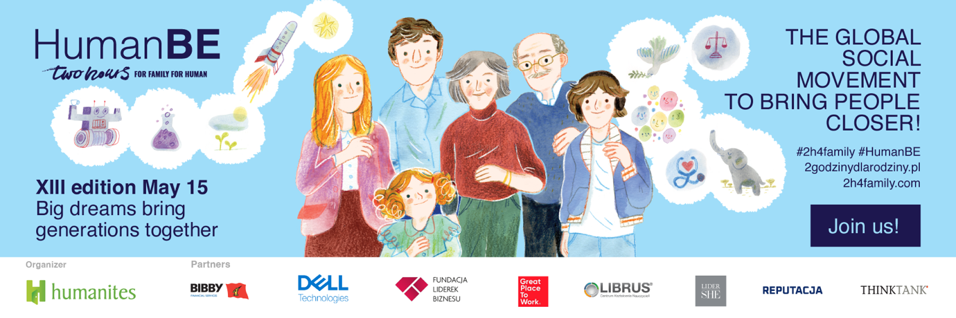
Dear Friends,
we are very pleased to announce that (once again) we are participating/joining the "#2h4family/ #HumanBE" campaign organized by the Humanites Institute - Human&Technology.

Two Hours for Family | HumanBE
To be closer and not next to each other at home and at work
This is the Global Social Movement for Proximity, launched 12 years ago in response to the growing phenomena of loneliness, depression, and human bonding crisis.
The goal of the Action, and the reason for our participation, is to support the Great Social Change of work culture and lifestyle so that building meaningful relationships with family, loved ones and at work is easier. We are happy to be part of this important project!

What does participation in the campaign entail for you?
What the company_organization wants to give you is, in essence, priceless. The symbolic two hours off, which space to explain the rules of their collection, such as you can pick up on May 15 or on a day of your choice, we suggest you devote to your loved ones. We want you to build good ties not only in the workplace, but also in the family, among friends and acquaintances.

Through the "Two Hours for Family / #HumanBE campaign, we urge you to spend quality time with your loved ones: during your favorite activities, for a good, longer conversation. When was the last time you learned something new from your loved ones? Spend this time preferably intergenerationally!

The symbolic "two hours" is only part of the Action. We have prepared a number of attractions especially for you. A place to present a unique program of action within a particular company / organization.

[Option for companies that have purchased ASK ME cards] Finally - we want to give you Ask Me cards. We purchased them for you to support you in nurturing relationships. This simple, yet extremely engaging game gives you the opportunity to get to know your loved ones better. It has no points, no competition and no losers. It's a game where the conditions are dictated by curiosity about the other person, their experiences, memories and dreams.

We very much hope that the #2h4family action will give you and your loved ones a lot of joy. Remember - you are for the company_/ organization /_us not only employees, but first of all - people. Fathers and mothers, sons and daughters, citizens and citizens.

Through our action, we want to show that we know this and your satisfaction with your non-work life is important to us.

The motto of this year's #2h4family #HumanBE is:
Big dreams bring generations together.

Making dreams come true together is a great way to spend time with family or friends. And desires big and small are a great topic of conversation that strengthen bonds! What are your dreams? What do your loved ones dream about?

Do you want to learn more about your loved ones? Do you need inspiration for a good conversation that strengthens relationships?

Talk about dreams, we suggest you answer the following questions:
- What did you dream about as a child? And what do you dream about now?
- Have three wishes for Alladin's Lamp. What will you ask for?
- Do you have a family dream? Tell us about it!
- You and your loved ones get a once-in-a-lifetime opportunity for a trip to any place on Earth. What location do you choose for you and why this one?
- Do dreams bring people together? What do you think about this topic?
- Finish the sentence "Dreams for me are...".
- List three things that are most important to you in life and justify your choice.
- If you could add one talent or skill to yourself - what would it be? Fluent French, beautiful singing, mathematical ability, sports ability, or something else? Where did your choice come from?
- You have the opportunity to solve one problem that plagues the world, without any negative consequences. What do you choose and why this?
- You go to a desert island and can only take 5 items with you. Which do you choose and why?
- Have you ever managed to fulfill someone else's dream? Tell us about it!
- What species from prehistoric animals should scientists resurrect?
- A small dream and a big dream. Every person has at least one such and one such. Tell us about yours!
- For one day you can become any person of the current living in Poland or the world (artist, athlete, scientist, etc.)? Who will you choose and why?
- What book hasn't been written yet, what movie hasn't been made? What will you propose? Put your imagination to work!
- Are you the type of dreamer or dreamer? Or are you rather hard-headed? Tell us why you rate yourself this way.

We encourage you to talk to your relatives, family, and friends about these issues. Be sure to call your grandparents!
Warm wishes!
.........................................................

