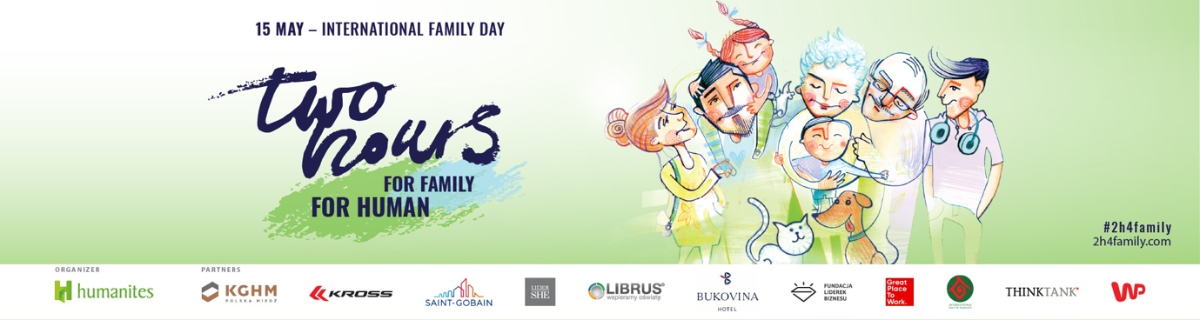
BECOME AN AMBASSADOR OF OUR CAMPAIGN “Two Hours for Family”
E-mail example for your company’s foreign branch / headquarters etc.:

We are participating in a social campaign “Two Hours for Family” for XXX years.
The aim of the campaign is to bring people closer in today fast running world. Inspire what it takes to build close relationships, show that as little besides the good will and true attention! The campaign was developed by Humanites Foundation in 2011. The campaign has permanently inscribed in calendar of our company events. Our employees appreciate this initiative very much. Last year, the Two Hours for Family campaign was mentioned in the top of the expected non-financial benefits by employees in Poland. People share memories, stories, get closer in their families and at work.
The campaign over the time developed into a social movement and reaches over 14 million Poles through the media. Those “two hours” on May 15th have become for all of us a symbol of closeness, relationships and integration of work and family life.
In 2017, the campaign went beyond the Polish borders. As partners and ambassadors of this action, we would like to inspire you to join this global social movement.
By joining “Two hours for Family” the company has a chance to:
- Execute in practice the Human Economy – showing that we are not hiring employees but people with their crucial social roles of parents, children, grandparents, relatives, etc.
- Show how it values employees’ families (Employer Branding)
- Develop activities for employees’ families (CSR)
- Inspire employees to build stronger bonds with their families and co–workers (Employee Engagement)
- Draw the attention to work life integration issues (Life balance)
- To get the best wellness program in the world (Wellness 3.0)
- Contribute to the emotional and mental health of our employees and society!
The details of the campaign, its objectives, levels and benefits for the company and employees can be found in this presentation: Bringing People Closer_Join the Global Social Movement_Two Hours for Family.
Information about campaign initiator, Humanites Institute, you can find here.
Please, feel free to contact directly Humanites coordinator of this campaign:
Katarzyna Lorenz – katarzyna.lorenz@humanites.pl
