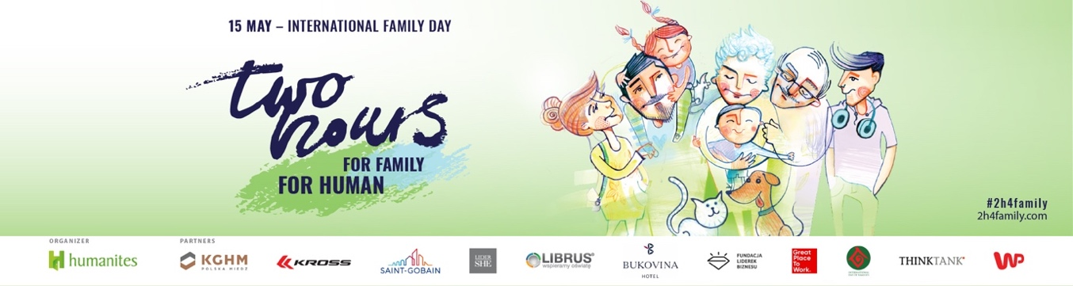
Ladies and Gentlemen,
we are pleased to invite all employers to participate in the 10th edition of the Global Social Movement initiated by the Humanites Institute “Two Hours for Family”, which is aimed at bringing people closer and taking care of human well-being. Our Action has been striving to prevent the crisis of bonds and the growing phenomenon of loneliness as well as to show the impact of these phenomena on our mental and physical health, and consequently, on the commitment and motivation to work and life.
Already 10 years ago, despite the initial scepticism towards our Action, we introduced the topic of the family to the business. We’ve been showing employers the significance of wise integration of professional and private life in accordance with the thesis that we have one life in different roles – as an alternative to the so-called work-life balance, which in its construction assumes dichotomy and a competitive approach of the two spheres.
2022 is another year when employers are dealing, with huge challenges: pandemic effects, labour market trends: "the great resignation ", "the employee market"... In February the world was shocked by the war in Ukraine.
In times of rapid and unexpected changes, on the one hand: it is extremely difficult to plan, think long-term and maintain the normal functioning of a company. On the other hand, it is important to keep employment stable, motivate employees and care for their high level of engagement. In a situation of dynamic circumstances, the question of how to build a work culture in which business will pursue its goals and people will find a sense of meaning becomes more crucial than ever before. At the Humanites Institute, we have been supporting Polish employers with building a high management culture for over a decade. Through our #2h4Family campaign, we show that macro changes result from the impact at the micro level – that a happy person is also a better, more creative employee, parent, and community member.
It is Thanks to you, Employers, #2h4Family campaign has grown not only in Poland but also celebrated by employers already from 18 countries around the world. We are glad that our activities have been appreciated by awarding the Humanites Institute in 2020 with the title of the Institution “For the Common Good”. This is a success not only for us but for you - all responsible Employers!
Our Reality
After the pandemic, society - and our employees, all of us - are exhausted And because of the war, our fears and anxieties do not disappear, but grow. The conditions in which we operate today are not favourable for building family ties and strengthening relationships. Absorbed in the virtual world and global topics, we are losing our loved ones and families with their multi-generational roots.
According to the latest Humanites report: "Well-Working Corporate Family Responsibility 2022", up to 93% of people surveyed feel pressured to choose work over private life.
Today it is necessary to create a culture of well-being, long-term strategies that take a multidimensional approach to people and support them in all their life roles: professional, family, and private.
- If we want our employees to be motivated and engaged let's help them develop in other roles, not only professional ones. - said Zofia Dzik, President of the Humanites Institute, Impact Investor - Because no matter what motivational systems we build in a company, but most inefficiencies at work also come from the fact that we have different challenges at home. The level of life energy and motivation comes from how we feel: whether we have a sense of meaning or not; whether we have power to get out of bed. The survey results show us a strong link between well-being at work and focus on responsibilities, levels of enthusiasm, high intensity work, creativity, and employee engagement.
The pandemic has only highlighted what we have been observing for some time: a life of high speed, the scale of depression or loneliness. A war in Europe will further intensify these worries and fears. Today, the key is smart practices that support the mental and physical wellbeing of workers and their families. In the coming weeks and months, it is the decisions of managers and leaders that will have big impact on the employees and their families, in the end, on the whole society. In a group of experts, we discussed this topic during the IX Conference of the Humanites Institute MAN AND TECHNOLOGY: how huge responsibility is in the hands of leaders and employers.
Two Hours for Family, Two Hours for HUMAN is a global social movement initiated by the Humanites Institute for deep family relations, to be together, not just “next to each other”. Another year, we extend the family context to other people around us: at work, in the neighbourhood – as a kind of members of our family. The action Two Hours for Family, Two Hours for HUMAN globally counteracts the crises of ties, has a preventive effect when it comes to our physical and emotional health.
Global Reach
The 2h4family campaign since its initiation by Humanites has entered the calendar of 18 countries around the world, thus creating a global social movement for deepening relationships with our loved ones. Over the years, the number of employers actively participating in the “Two Hours for Family” campaign has been systematically growing.
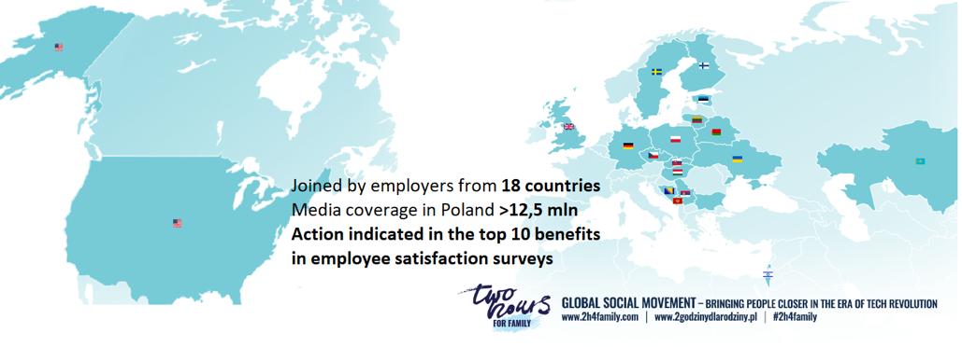

Benefits for the Company
Employers’ concern for creating a space conducive to combining the professional and family spheres has a direct impact on the effectiveness and achievement of the company’s economic goals and on the development of social competences of the next generations.
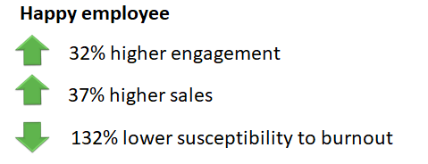
Gretchen Spreitzer and Christine Porath,Creating Sustainable Performance , Harvard Business Review
Currently, the biggest motivation for people on the labour market is the possibility of self-fulfilment, a sense of meaning, while the family is a very important part of their lives.
In our opinion, business is a key force of positive social change, therefore:
For the sake of your employees and company goals – join us!
- By creating a long-term employment policy focused on human well-being based on good standards of combining professional and private roles. The collection of good practices created by the Humanites Institute based on the results of the Competition for a Family-Friendly Company/Human Friendly company can be inspirational here (read more: https://2godzinydlarodziny.pl/co-wyroznia-firme-przyjazna-rodzinie-czlowiekowi/)
- Inspiring your employees to have a good conversation with their relatives, to arouse their curiosity, to build rituals that strengthen bonds and spend their time qualitatively. By creating a space to deepen relationships with colleagues at work. A human-human meeting, not only position – position.
The finale of the Two Hours for Family campaign, which takes place on 15th May, is a perfect opportunity for this. On this day, most employers, as part of the 2h4family celebration, allow employees to take two additional hours off from work, provided that this time is spent on caring for relationships with the loved ones.
Our initiative to bring people together at home and work has a different theme every year. We build a narrative around it, encouraging the intergenerational discovery of each other in the work environment and in our families. This year’s theme was “Our Pets and Shared Moments.” It won a competition for a theme for the year #2022. Usually, the theme chosen in the round guided the campaign for the following year. We dedicated our campaign to Family and Human persons. Due to the Russian invasion of Ukraine, the world changed almost overnight for many people and families. In this challenging time of war in Europe, the support we receive from loved ones is essential, as is our support for others. These fundamental issues have always been at the root of the “2 Hours for Family/ For Human”. We decided to return to the original meaning of our action and bring back this cardinal but straightforward idea this year. It is essential to share good emotions, take care of family bonds, and show affection and empathy to each other on these sad days. That doesn’t mean we won’t talk about pets this year. After all, our pets are full members of our families, good friends. They encourage us to be active, shape our sense of responsibility and care and strengthen our bonds. First of all: this year, take care of yourself and your loved ones!
Feel free to contact us, we will be happy to answer any questions. More information and the application form can be found on www.2h4family.com. All #2h4family activities on behalf of the Humanites Institute are coordinated by Katarzyna Lorenz (katarzyna.lorenz@humanites.pl). We encourage you to share our invitation with your business partners and clients and thus inspire them to join “Two Hours for Family”.
With kind regards,
Zofia Dzik
President of the Board Humanites Institute
