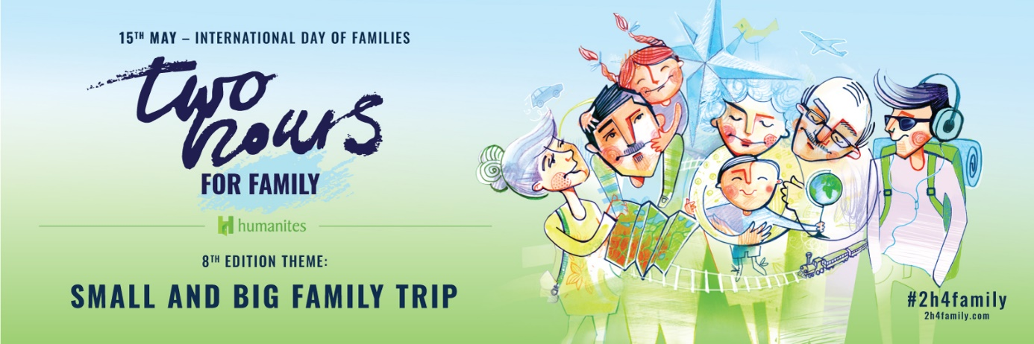

Ladies and Gentlemen,
we are pleased to inform you that our company also this year/ for the first time this year joins the action Two Hours for Family, organised for 8 years now by Humanites Foundation.
Two Hours for Family is a social movement devoted to deepening close relations between the loved ones from multigenerational perspective. It encourages families to be together, not just “next to one another”. The key date of this action, in which hundreds of employers from Poland and a dozen of other countries participate, is 15th May, International Family Day. This day, each employee of our company will have the possibility to leave work symbolically two hours earlier and spend this time with their nearest and dearest.
15th of May should become for us a day for reflection about our relations with people close to us. Let’s take a break for a second, let’s have a look at ourselves and our families, friends and co-workers. Let’s ask ourselves a question: when was the last time I showed interest in my friends’ and family’s life? How often do we talk about topics different from everyday ones, like shopping, laundry, additional classes for the children? When was the last time we did something new together?
Contemporary pace of life, stress, pressure that we are under make us pay less attention to our families and friends. We don’t have enough time to conduct a good conversation with them. Consequently, we start drifting apart, it’s getting harder to face problems, we lose contact with adolescent children, feeling as a result more and more lonely. We would like to contribute to a change of status quo. In a symbolic way, we create some space for it and encourage you to use the free afternoon on 15th May to have some multigenerational conversations, to play together or take a trip.
Each year, there is a main motive to the action, which is meant to bring people closer and encourage common activities. This year’s motto is: SMALL AND BIG FAMILY TRIP.
Family trips and travels – literally or metaphorically speaking, e.g. these could be travels in time, which build relations and bring family closer. We do believe that every single trip that
a family takes together, even if it’s just a walk to a park or ZOO, gives a lot of opportunities to see our loved ones in a different light and understand them better. Building closeness calls for interest, conversations, doing things together. Below you can find a few inspirations that we wish to share with you:
- Prepare a time capsule with letters to yourself and others from the past, illustrations of places important to you or with objects, souvenirs. Place these items in a big, glass jar and burry it e.g. in the garden in front of your house, in a characteristic place. Agree on some period of time, e.g. 5 or 10 years, when you dig the jar out and open it.

- Do you know, where your parents, grandparents, great grandparents were born? Do you know these places? What do you know about them? Maybe this is the right time to ask more detailed questions about the seniors in your family!

- Prepare common route maps. Mark places, which were most remarkable for you during family trips. These don’t have to be long journeys. These might be as well such points like theatres, parks, cinemas nearby. Most importantly, they should have
a magical meaning for you

Prepare with your relatives (maybe also record) an interview with your grandma, grandpa, other person from the family e.g. about first independent travels, places of birth, first jobs.

- What was the first car of your parents or grandparents? What memories do they have with it?

- Play all together hare and hounds. Parents could e.g. hide in different places in the house, garden or a park some riddles or ASK ME cards with questions and tips, where to find the next tasks.

- Look for pictures taken during family trips and holidays, prepare a memory board of the last 10 years and place in is some important place in your home.

- Ask your loved ones, which day from the last year they would like to re-live?

- Did any of your family members keep a journal or a notebook with memories? If yes, try to find it and check out, what’s inside.

- If you were able to choose any place to live on Earth or outside of it, what would that be and why?
These are just a few suggestions, how to spend time together. Humanites Foundation published more of them on its Internet website. Just click the link (www.2godzinydlarodziny.pl/inspiracje).
It’s up to you if and how you want to use them. Everyone has their own key to conversations with their loved ones. These two hours may build more than you might think. We hope that the symbolic two hours will inspire you to find the time to talk not only during holidays, but every week. Every day.

[opcja dla firm, które zdecydowały się na zakup kart dla pracowników]
On this occasion, we have prepared for you a special gift – a set of ASK ME cards. This very simple game offers an exceptional opportunity to get to know your loved ones better. There are no points, no competition, no winners or losers. It’s a fun game with the rules set exclusively by the curiosity of another person, their experiences and dreams.
Let’s play and popularise the idea of the action! Let’s inspire others! Play and have fun with your families, share with us your best questions, stories or pictures. Tag them with #2h4family and put them on social media. Let’s support the idea and let’s prove to others that Two Hours for Family truly bring people closer.

To finish off, let’s remind ourselves words by Marcel Proust – “The real voyage of discovery consists not in seeking new landscapes, but in having new eyes”.

Kind regards,

