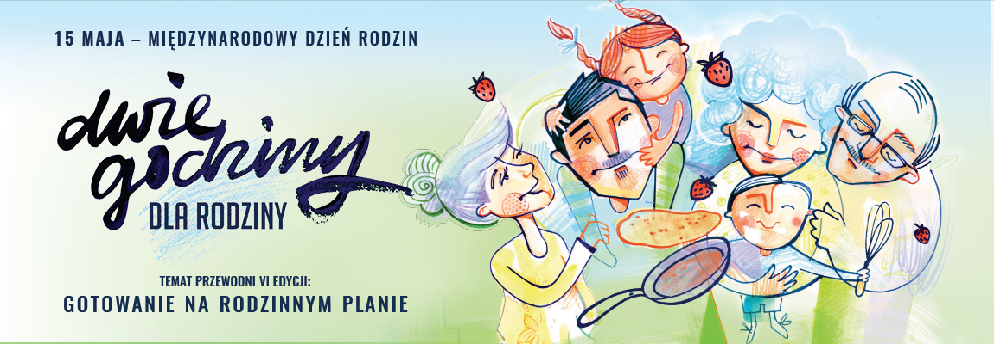

“TWO HOURS FOR THE FAMILY”
celebrate
the International Day of Families
with us

Together with the Humanites Foundation we would like to invite you to reflect for a moment on your family relationships. When was the last time you found out something about your loved ones? How do you spend time together? Does your life revolve around current organisational matters or do you have time for warm conversations which create a feeling of closeness and mutual trust?
6th edition of the campaign
COOKING WITH THE FAMILY
Company Name decided to reduce the working time for our employees by 2 hours on 15 May.
It is you who will decide how to use this time.
...because the Family is built on relationships
“Food is like love: it tastes good when we share it. Preparing a meal attentively and with care constitutes a tribute paid to oneself and others. This is how the cook expresses their feelings. This is why cooking is so absorbing and full of emotions.”
Kitchen is the heart of a home, it is associated with warmth, smells, friendly atmosphere, often the entire home and social life centres around the kitchen. So we would like to encourage you to cook together and then feast together. Let this time be filled with tastes, smells, colours. Share recipes, culinary secrets, childhood memories, and maybe yearning for forgotten dishes. Many family histories are connected with the table, food, and taste. Our cultural identity is also in the tradition of the table and food.
Inspirations for interesting conversations around cooking can be found at http://mamrodzine.pl
We have selected ones we thought most interesting.

- Prepare a meal and sit at the table together, try to create a festive setting.
- Tell one another about your favourite tastes, smells, culinary dreams and yearnings.
- Create a menu together for your children’s wedding.
- What is your favourite breakfast food?
- Have you ever had a culinary disaster? Tell them about it.
- What childhood dish do you miss the most?
- Do you like to cook? If so, talk about your passion. Where do you inspirations come from?
- Do you have your favourite restaurant, eatery? What makes it so charming?
- The worst dish you have ever eaten.
- What is your granny’s/mum’s specialty? Something that no one would prepare better.
- What are the culinary traditions connected with Christmas and Easter, or other celebrations in your family.
- What cuisine is your favourite, from what country, region?
- Share the secrets of your cooking.
- They say that you can get into people’s heart through their stomach – what dish would you cook to apologise to/appease your loved one?
We would like to persuade you to record these moments. The time passes so quickly, especially in relation to our Grandparents. Our suggestions are to encourage and stimulate your creativity, it is not important whether you will use them or find your own key to closeness. Family bonds are formed only when the family spends their time together and show one another love and interest. 15 May is a symbolic date – it depends on you whether it will become the beginning of a new tradition: TWO HOURS FOR THE FAMILY a week, a month or maybe even every day.
A small request from the Humanites Foundation – if our family is important to you and you see the crisis of deep bonds in the contemporary world, help promote the Day of Families and the value of inspiring moments with your loved ones. Share your suggestions, ideas, recipes or culinary memories on the Humanites Foundation Facebook page. Every comment is welcome
We would also like to encourage you to play together and to join the annual competition for the campaign motto for 2018. The main prize is the family weekend in Hotel Bukovina. We would be very happy if it were one of your proposals that gave us an inspiration to be together as a family and became the motto of Two Hours for the Family in 2018.
We are inviting you to use the Family Quiz – a list of questions which may be downloaded, printed, cut out and used to play with – just like playing cards.
Share the information about the International Day of Families among your family and friends. Maybe they will encourage their employers to join the 2 Hours for the Family Campaign. Become ambassadors of deep family bonds.
Details concerning the “Two Hours for the Family” campaign are available at www.mamrodzine.pl
We wish you good time and many emotions.

Management Board of (Company Name) and Humanites- Foundation
www.mamrodzine.pl

Joanna Szachowska-Tarkowska, Już nie jem sama (I no longer eat alone), in the Slow Life & Garden magazine

